**Points of Dispensing (POD) Locator**

Points of Contact:

Eva Islam ([eislam@health.nyc.gov](mailto:eislam@health.nyc.gov))

Mustafa Ali ([mali2@health.nyc.gov](mailto:mali2@health.nyc.gov))

DOITT Ticket Number: KSR000001698132

Expected Completion Date: June, 2019

**Table of Contents**

I. Overview………………………………………………………………………………………………...1

II. Expected Data Flow…………………………………………………………………………………...2

III. Requirements………………………………………………………………………………………….3

IV. Appendix……………………………………………………………………………..………………12

**Version History**

|  |  |  |  |
| --- | --- | --- | --- |
| **Version Number** | **Version Author** | **Changes Made** | **Date Updated** |
| 1.1 | Eva Islam | Initial Draft | 2/12/2019 |
| 1.2 | Eva Islam | Updated | 3/1/2019 |
| 1.3 | Eva Islam | Updated | 3/15/2019 |
| 1.4 | Eva Islam | Updated | 3/28/2019 |
| 1.5 | Eva Islam | Updated | 4/16/2019 |
| 1.6 | Mustafa Ali | Updated | 4/17/2019 |
| 1.7 | Eva Islam | Updated | 4/30/2019 |
| 1.8 | Eva Islam | Updated | 5/9/2019 |
| 1.9 | Eva Islam | Updated - UAT | 5/15/2019 |

**I. Overview**

The Bureau of Emergency Field Operations (BEFO) at the New York City Department of Health and Mental Hygiene (DOHMH) is requesting the creation of a Points of Dispensing (PODs) Locator. The goal of the Locator is to allow members of the public to identify and find their nearest POD Site before and during an emergency. The Locator should allow individuals to search for their address and determine directions to a nearby POD Site. It should also display relevant details such as a POD site’s address as a pop-up on the map, and in list form. Given that this will be a public-facing application, the Locator must be Section 508 Compliant to ensure that it is accessible to individuals with disabilities.

This project is related to the POD Management Tool, an ESRI based product that leverages Survey123 and ArcGIS to enable DOHMH staff members to report operational information from active POD sites. The Locator should mirror the interface and functionality of the NYC Hurricane Evacuation Zone finder[1].

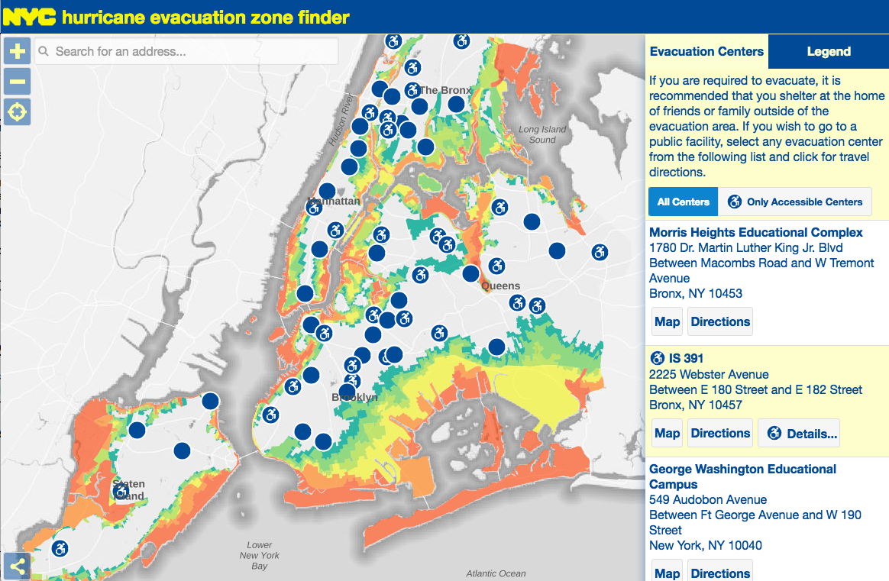

**II. Expected Data Flow**

The Locator should read directly from DOHMH’s ArcGIS Online Locator layer[2]. During a POD activation, staff members at active POD Sites will report out on various indicators including the site’s operations status and its wait time. Individuals will be able to input data directly into their smart phones via Survey123, a form-centric data collection application for ArcGIS Online. Once they have submitted information into the mobile application, the data will populate feature layers in ArcGIS Online. A python script then pushes and pulls these data between ArcGIS Online and a SQL Server database at DOHMH. The Locator layer (*vwLatestDateLocator*) is one of several SQL views that pushes into a feature layer in ArcGIS Online.

ArcGIS Online

DOHMH SQL Server Database

Survey123

(Smart Phone)

DOITT Locator Tool

(maps.nyc.gov)

The POD Locator REST layer is currently public and accessible to anyone on ArcGIS Online. The layer contains the following fields (the bolded fields are collected via Survey123 during an activation):

|  |  |  |  |
| --- | --- | --- | --- |
| **REST URL Field** | **Field Type** | **Length** | **Description** |
| *DOECode* | esriFieldTypeString | 4 | POD site’s 4-character DOE code |
| *PODSiteName* | esriFieldTypeString | 150 | POD site’s name (starting with DOE Code) |
| *Address* | esriFieldTypeString | 50 | POD Site’s Street Address |
| *Borough* | esriFieldTypeString | 15 | POD Site’s Borough |
| *ZIP* | esriFieldTypeString | 5 | POD Site’s Zip Code |
| *Latitude* | esriFieldTypeDouble | -- | POD Site’s Latitude |
| *Longitude* | esriFieldTypeDouble | -- | POD Site’s Longitude |
| ***Ops_status*** | esriFieldTypeString | 16 | POD Site’s Operational Status |
| ***wait_time*** | esriFieldTypeInteger | -- | POD Site’s Wait Time |
| ***LatestDate*** | esriFieldTypeDate | 8 | Date/time data was last updated on Survey123 |
| ***OpeningTime*** | esriFieldTypeDate | 8 | Expected date/time of POD Site’s Opening |
| *DOHMHPODLink* | esriFieldTypeString | -- | DOHMH Points of Dispensing Web Page |
| *ActivePOD* | esriFieldTypeInteger | -- | DOHMH Internal Operational Status  (0 = Inactive, 1 = Active) |
| *LabelPos* | esriFieldTypeString | -- | Label Position Indicator  (E = right, W = left, N = above, S = below) |

**III. Requirements**

Overview of Requirements:

|  |  |
| --- | --- |
| **#** | **Description** |
| 1 | Locator can rapidly switch between two states following a POD related emergency:  (a) Pre-Activation State  (b) Activation State |
| 2 | Locator can hide data, and change symbology depending on its state |
| 3 | Locator allows users to view POD sites closest to a specified address and obtain directions to a POD site |
| 4 | General Requirements for POD Locator |
| 5 | Locator must be Section 508 compliant and pass review by the NYC DOHMH Communications Office |

*Requirements #1 – Locator can rapidly switch between two states following a POD related emergency: (a) Pre-Activation State (b) Activation State*

Similar to the NYC Hurricane Evacuation Zone finder, the POD Locator must be able to switch between a non-emergency and an emergency state. The Pre-Activation state should display all 165 sites at all times. In Pre-Activation mode, all PODs on the map should have an *ActivePOD* value of 1 in the REST layer. The Activation state should hide all inactive POD sites from the map.

1. Pre-Activation State:

In this state, the goal of the Locator is to familiarize members of the public with their closest POD site in the event of an emergency. The Locator should display the *PODSiteName* and *Address* and allow individuals to search for directions from their home/work to a nearby POD site.

1. Activation State:

When PODs are activated, the Locator should hide data for inactive POD sites from the Locator and display active ones as either “Opening Soon, “Open to Public” or “Closed to Public” on the map. The pop-ups and details section should display the appropriate fields from the REST layer depending on the site’s Status. The routing functionality should remain the same as in the Pre-Activation State.

*Requirements #2 – Locator can hide data, and change symbology depending on its state*

1. Pre-Activation State:

**Symbology**:

The sites should have the following symbology when PODs are not active:

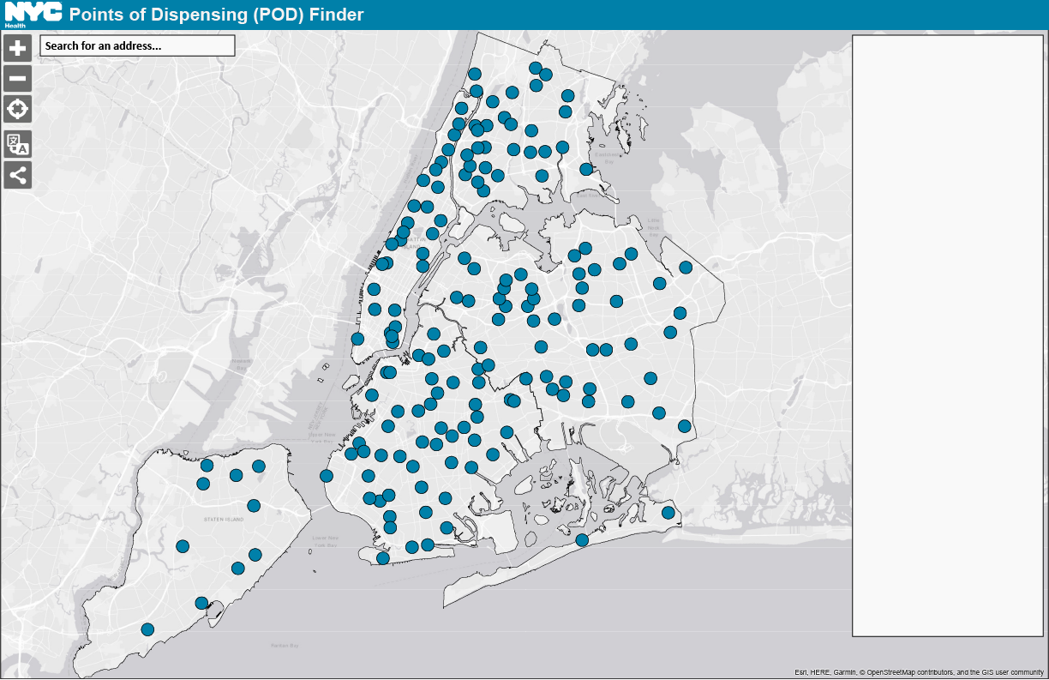

Pre-Activation State:

*Outline color*: #1A1A1A

*Fill color*: #0080A9

*Symbol size*: Same size as symbols in NYCEM Hurricane Evacuation Zone Finder

**Labels**:

Each POD site should have a corresponding label on the map with its full name (*PODSiteName*) when the user is zoomed in to a certain extent. Ideally, this would be close enough such that the user is only viewing a few points on the map. The labels from neighboring POD sites should not overlap with each other. If they do, the *LabelPos* value for the site needs to be readjusted in the REST layer. The default value is E (label positioned to the right of the site), but this can be changed (see Part II for more information).

**Tooltips:**

In the absence of an activation, the tooltips should display the following fields when the user hovers over a POD site in a web browser. There should also be text in the tooltip that directs the user to click on the site for directions.

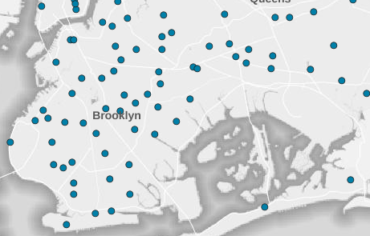

**[POD Site Name]**

[Address]

[Borough], NY [ZIP]

*Click on site for directions*

**Pop-Ups and Panel:**

When PODs are not activated, the pop-up for each POD site should only list its address. Similarly, the panel on the right side of the map should only display the site’s address and no other details.

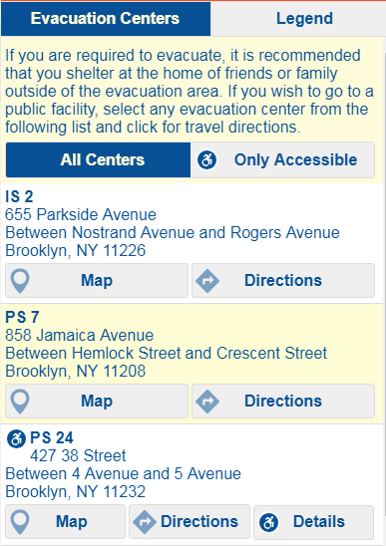

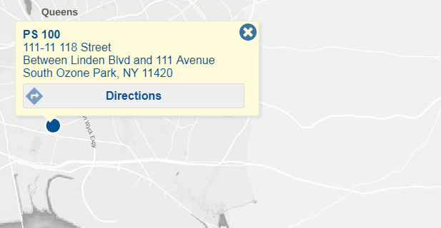

Pre-Activation State:

**[POD Site Name]**

[Address]

[Borough], NY [ZIP]

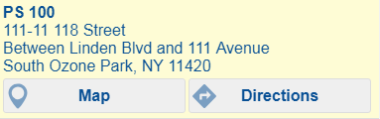

1. Activation State:

**Symbology**:

Following an activation, the Locator should hide any sites that are listed as *Inactive* or without a value (*NULL*) in the REST layer. The POD sites that have statuses listed as either *Open to Public*, *Mobilizing*, *Demobilizing*, *Demobilized*, or *Closed to Public* in the REST layer should be displayed as either “Opening Soon, “Open to Public” or “Closed to Public” on the map. Sites should be grouped by their *Ops_Status* values as denoted below:

|  |  |  |  |  |
| --- | --- | --- | --- | --- |
| Ops_status value | **Hidden** | **“Opening Soon”** | **“Open to Public”** | **“Closed to Public”** |
| Open to Public |  |  | X |  |
| Mobilizing |  | X |  |  |
| Demobilizing |  |  |  | X |
| Demobilized |  |  |  | X |
| Closed to Public |  |  |  | X |
| Inactive | X |  |  |  |
| *NULL* values | X |  |  |  |

The points should be color coded as follows:

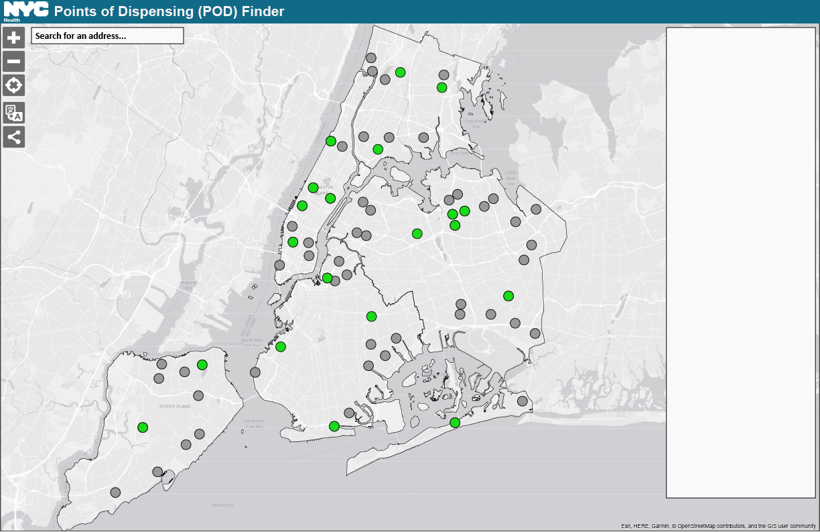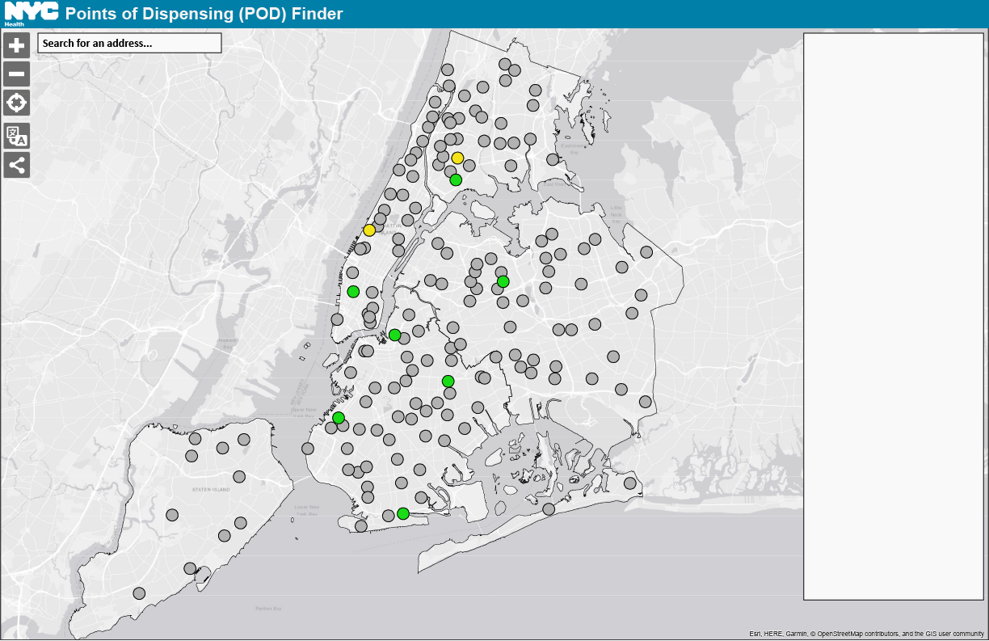

Activation:

**Opening Soon**

*Outline color*: #1A1A1A

*Fill color*: #F3E318

**Open to Public**

*Outline color*: #1A1A1A

*Fill color*: #19DB17

**Closed to Public**

*Outline color*: #1A1A1A

*Fill color*: #999999

*Symbol size for all symbols*: Same size as symbols in NYCEM Hurricane Evacuation Zone Finder

**Labels**:

Like in the Pre-Activation state, the map should display a label with the POD site’s full name (*PODSiteName*) next to the site on the map. The labels should appear at the same zoom extent, format and position as in the Pre-Activation state.

**Tooltips:**

During an activation, the tooltips should display a POD site’s name and address, its status and the fields that would be displayed in the Details section (see following section for more information). There should also be text in the tooltip that directs the user to click on the site for directions.



**[POD Site Name]**

[Address]

[Borough], NY [ZIP]

**Status**: [Ops_status]

Fields from Details section

*Click on site for directions*

**Pop-ups and Panel**:

Once PODs have been activated following an emergency, the pop-ups and panel should display the following fields in the Details Section for active POD sites. The Details section should not be minimized by default. The fields displayed in the Details section should vary by the POD site’s *Ops-Status.*

|  |  |  |  |
| --- | --- | --- | --- |
| Field Alias (field in REST URL) | **“Opening Soon”** | **“Open to Public”** | **“Closed to Public”** |
| Wait Time (*wait_time*) |  | X |  |
| Estimated Opening Time (*OpeningTime*) | X |  |  |
| Last Updated (*LatestDate*) | X | X | X |

Activation:

**[POD Site Name]**

[Address]

[Borough], NY [ZIP]

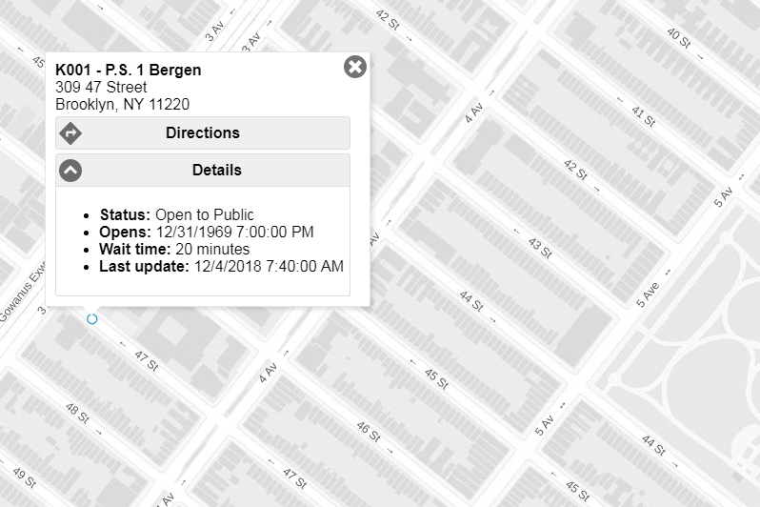

Activation:

If *Ops_status* = **Opening Soon**,

* **Status**: [*Ops_status*]
* **Estimated Opening Time**: [*OpeningTime*)
* **Last Updated**: [*LatestDate*]

If *Ops_status* = **Open to Public**,

* **Status**: [*Ops_status*]
* **Wait Time**: [*Wait_Time*)
* **Last Updated**: [*LatestDate*]

If *Ops_status* = **Closed to Public**,

* **Status**: [*Ops_status*]
* **Last Updated**: [*LatestDate*]

Activation:

Same as pop-up’s information

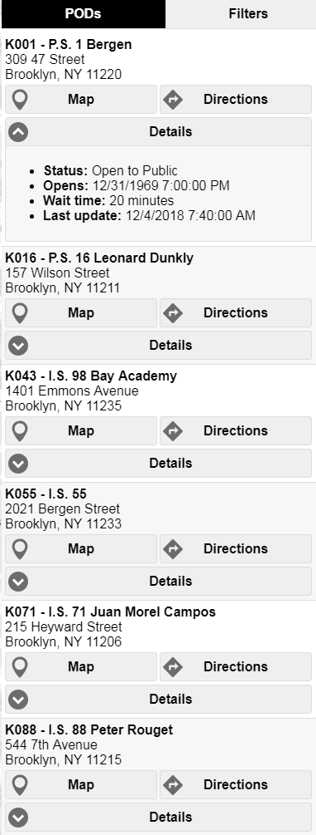

Activation:

Same as pop-up’s information.

In the Activation state, the panel should include several unique features:

(i) A Legend in the PODs tab that details what the operational statuses the different colored symbols on the map correspond to.



(ii) A Filters tab that allows the user to filter the POD sites on the map by status, and by borough. The borough filter should be displayed first, followed by the status filter.

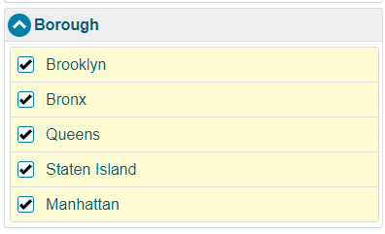

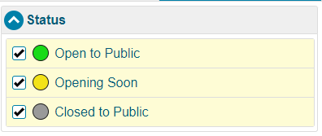

(iii) Each site on the panel should display its corresponding symbol on the map (color coded by status) next to the site name on the panel. The symbol should be aligned to the left of the site name and address as displayed below:

* **Status:** Opening Soon
* **Opening at:** 4/5/2019 12:30:00 PM
* **Last Updated:** 4/4/2019 11:55:30 AM



*Requirements #3 - Locator allows users to view POD sites closest to a specified address and obtain directions to a POD site*

Both states of the Locator should allow for the same routing and directions functionality. Users should be able to specify an address in the Search Bar, and the Locator should subsequently zoom to that address on the map. The zoom extent should always include the 3 closest POD sites for the user’s specified address.

Once the Locator displays the closest PODs, the user should be able select one of the sites and determine directions to it from their original address via public transit, driving or walking. In terms of routing, DOHMH would prefer that the Locator automatically default to walking for all requests.

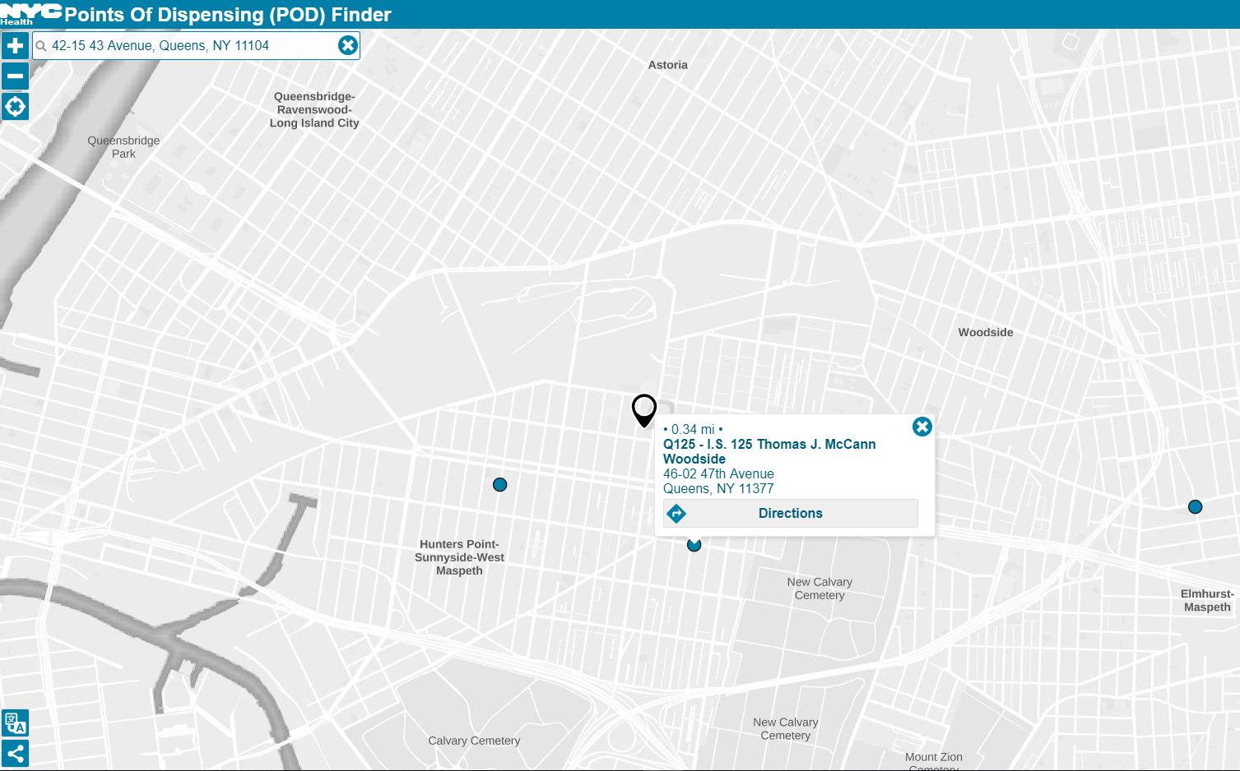

When the user clicks on Directions, the Locator should display the destination site on the map, even if the user has not to put in the starting location.

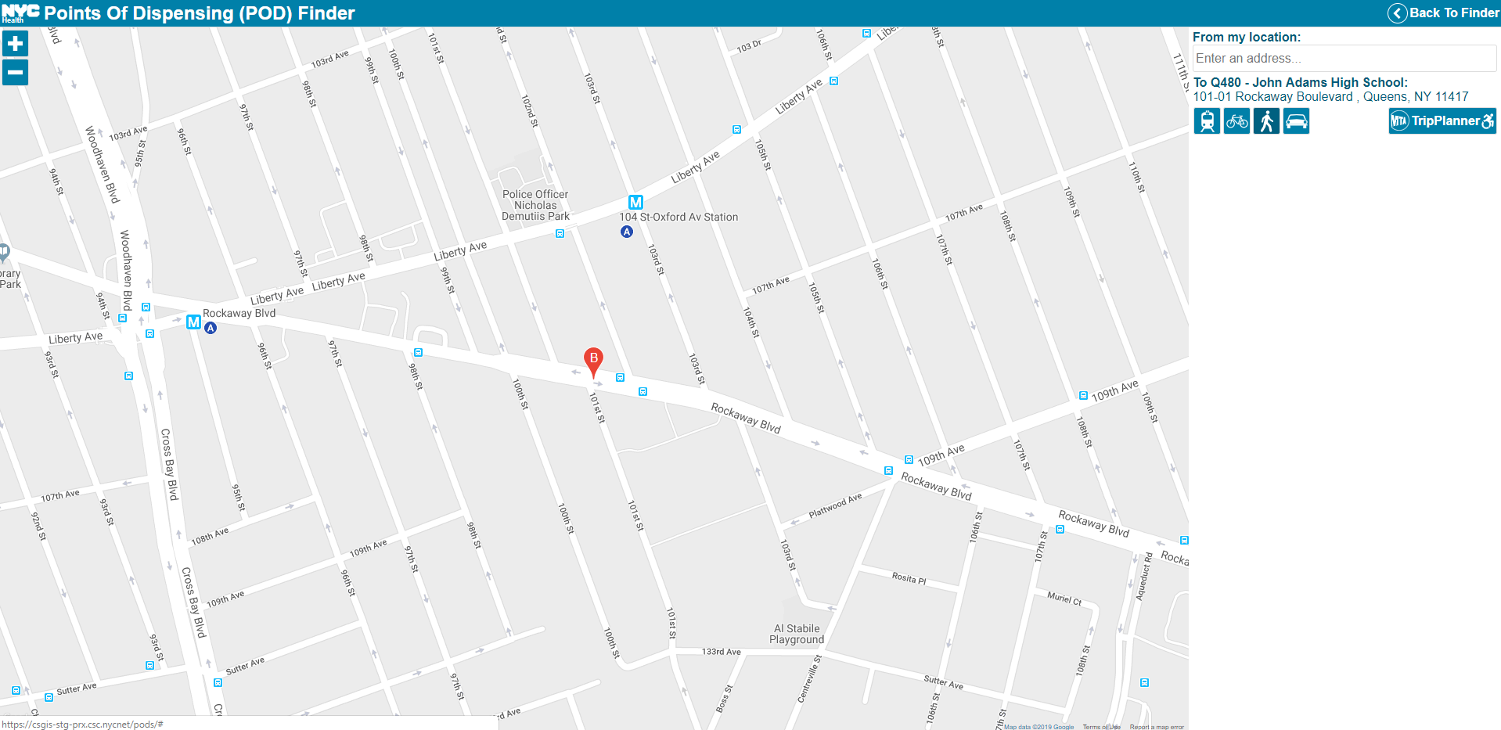

*Requirements #4 - General Requirements for POD Locator*

The following items should always appear on the Locator:

1. The banner at the top of the Locator should say “NYC Points of Dispensing (POD) Finder” at all times. This text should be bolded. The color of the banner should match the teal color from the “Emergency Medication Distribution: Points of Dispensing (PODS)” page on the DOHMH website: #0080A9.[3]
2. The text above the panel should be left aligned and say the following at all times:

“All Points of Dispensing sites may not be activated at the time of an incident. Please continue checking this page to see which sites are activated following an event.”

[break]

“Click on the NYC Health Logo to refresh the map”

0

All Points of Dispensing sites may not be activated at the time of an incident. Please continue checking this page to see which sites are activated following an event.

Click on the NYC Health Logo to refresh the map.

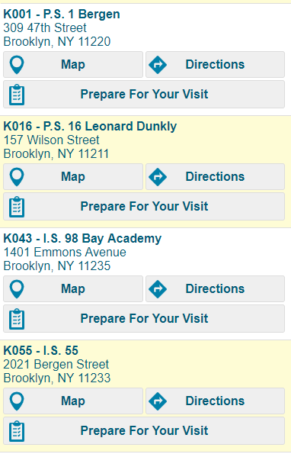

1. There should be a Home button or something similar that zooms the user back out to show the full extent of the map with all 165 POD sites.
2. The text on the splash page should say:

“Points of Dispensing (PODs) are temporary sites that are ready to open to provide life-saving medications to anyone who needs them after a biological attack or during a communicable disease outbreak. The sites are located throughout the city and are run by the NYC Department of Health and Mental Hygiene. All NYC POD sites are wheelchair accessible. For more information, please visit our webpage3.”

[break]

“No POD activation is currently in place.”

1. Hovering over a site on the Panel should cause the site on the map to light up via a halo. The halo should surround the POD site, and stand out against the base map. Given the current symbology of the map, blue and yellow are likely not good colors for the halo.
2. There should be a button on each site’s pop-up, and on the panel called “Prepare for Your Visit”. The button should direct the user to the DOHMH Points of Dispensing web page.[4]

*Requirements #4 – Locator must be Section 508 compliant and pass review by the NYC DOHMH Communications Office*

The Locator should incorporate the following items to ensure that it is Section 508 compliant:

1. Visual accessibility: colorblind safe symbology, high color contrast, accessible fonts
2. Screen reader accessibility
3. Text labels for all links, buttons and form controls
4. Keyboard navigation

The tool should also reflect DOITT’s recommended enhancements for accessibility:

1. The application should shift screen reader focus as necessary when a user is looking for a nearby POD site and when they are searching for directions. However, the legend should be hidden from screen readers.
2. The alt-text should correspond to all images and icons in the application.

**IV. Appendix**

1. NYCEM Hurricane Evacuation Zone Finder (Production):

<https://maps.nyc.gov/hurricane/>

1. DOHMH Locator Layer (*vwLatestDateLocator*) REST URL (No token required): https://services3.arcgis.com/A6Zjpzrub8ESZ3c7/ArcGIS/rest/services/vwLatestDateLocator/FeatureServer
2. DOHMH Points of Dispensing Web Page:

<https://www1.nyc.gov/site/doh/health/emergency-preparedness/emergency-medication-distribution.page>

1. DOHMH Locator Prototype (ArcGIS Online Webapp): <https://nycdohmh.maps.arcgis.com/apps/webappviewer/index.html?id=e4955603fe704405b5f79414e9916600>
2. DOITT POD Finder (Prototype - Development):

<https://csgis-dev-web.csc.nycnet/gis/data/apps/mobile/pods/>

1. DOITT POD Finder (Prototype - Staging):

<https://csgis-stg-prx.csc.nycnet/pods/>

1. DOITT POD Finder Data Uploader (Staging):

<https://csgis-stg-prx.csc.nycnet/uploader>

|  |  |  |
| --- | --- | --- |
| **DOHMH Users** | | |
| 1 | Eva Islam | [eislam@health.nyc.gov](mailto:eislam@health.nyc.gov) |
| 2 | Gaelle Pierre | [gpierre1@health.nyc.gov](mailto:gpierre1@health.nyc.gov) |
| 3 | Mustafa Ali | [mali2@health.nyc.gov](mailto:mali2@health.nyc.gov) |
| 4 | Jessica Barcellona | [jbarcellona@health.nyc.gov](mailto:jbarcellona@health.nyc.gov) |
| 5 | David Starr | [dstarr@health.nyc.gov](mailto:dstarr@health.nyc.gov) |

1. DOITT POD Finder Data Uploader (Production):

TBD

1. POD Locator Data Spreadsheet:

[S:\EPR\BEM\CRU\Technology & Data\POD Site Locator\content.xlsx](\\\\nasprgshare220\\Share\\EPR\\BEM\\CRU\\Technology & Data\\POD Site Locator\\content.xlsx)

1. NYCEM Hurricane Evacuation Zone Finder (Appendix (1))
2. DOHMH Locator Layer (*vwLatestDateLocator*) REST URL (Appendix (2))
3. 3 DOHMH Points of Dispensing Web Page (Appendix (3))
4. 4 DOHMH Points of Dispensing Web Page (Appendix (3))